 | Journal of Sustainable Digital Futures  journal homepage: https://jsdf.org.tr/ | 

Title of the paper (Bold, 12 pt. Only the first letter and proper nouns are capitalized)

Author Name SURNAME¹ , Name SURNAME² , Name SURNAME³ (11 pt.)

To add a hyperlink to icon , right click on the icon, open “Edit Hyperlink” and copy your ORCID link in the “Address” section (Please, erase!).
H I G H L I G H T S
¹ University, Department, Country, e-mail (9 pt.)
² University, Department, Country, e-mail (9 pt.)
³ University, Department, Country, e-mail (9 pt.)
A R T I C L E I N F O |  | A B S T R A C T
Keywords:  3-5 keywords,  10 punto  Only the first letter is capitalized. |  | An abstract not exceeding 250 words should contain some basic information of the paper only in English. The abstract must be written in Times New Roman font size 10. The abstract must have single line spacing and 6 pt spacing before and after. An abstract not exceeding 250 words should contain some basic information of the paper only in English. The abstract must be written in Times New Roman font size 10. The abstract must have single line spacing and 6 pt spacing before and after. An abstract not exceeding 250 words should contain some basic information of the paper only in English. The abstract must be written in Times New Roman font size 10. The abstract must have single line spacing and 6 pt spacing before and after. An abstract not exceeding 250 words should contain some basic information of the paper only in English. The abstract must be written in Times New Roman font size 10. The abstract must have single line spacing and 6 pt spacing before and after. An abstract not exceeding 250 words should contain some basic information of the paper only in English. The abstract must be written in Times New Roman font size 10. The abstract must have single line spacing and 6 pt spacing before and after. An abstract not exceeding 250 words should contain some basic information of the paper only in English. The abstract must be written in Times New Roman font size 10. The abstract must have single line spacing and 6 pt spacing before and after.

1. Introduction (First-Order Heading, Bold, 11 pt. only the first letter is capitalized, left-aligned)

The entire article must be written in Times New Roman font size 11. Headings must have 6 pt spacing before and after. The text must have single line spacing; paragraphs must have 0 pt spacing before and after. Indents must be 0 cm on the right and left, and 0.5 cm on the first line. The paper must be written in English. Spelling and grammatical errors, as well as language usage problems, is on the responsibility of the authors.
Tables and Figures should be cited in the text and placed after their first reference. They should be numbered using numerals. Tables should present new information rather than duplicating what is in the text.
Figures should be in high resolution. Equations are numbered in parentheses to the right; they are referred to in the text as Equation (1), Equation (2a), etc., with parentheses. Footnotes should be avoided.
Each new section and subsection should have a heading consisting of an numeral followed by a period. Please a single space before and after the section title (see this template).
.
.
.
.
.
.
For Example:
Environmental sustainability is a critical aspect of the Sustainable Development Goals (SDGs) and has increasingly garnered scientific interest in recent years (Mishra et al. 2024). Globally, nations are integrating efforts to develop sustainable industrial practices and enhance living standards, given that environmental degradation poses a substantial threat to human well-being. Effective management of carbon emissions, in particular, is vital for improving public health and advancing the SDGs (Mensah 2019).
Many studies focus on examining the key factors underlying renewable energy consumption (Hoa et al. 2023). For example, Salim and Rafiq (2012) demonstrate that economic growth fosters increased renewable energy consumption. Building on this, Okada and Semreth (2017) found that the availability of natural resources enhances the use of renewable energy. Sharma et al. (2021) provide evidence that capital formation supports the demand for renewable energy within BRICS economies. For example, ASEAN countries have taken steps to improve energy efficiency and diversify energy supplies, including developing renewable energy sources, with trade and international cooperation playing a key role in advancing clean energy initiatives in certain countries within the region (Lean and Smyth 2010).
Detailed information on the variables is presented in Table 1. The equation used to estimate the model is shown in Equation (1). The publication of the studies analyzed within the scope of the study by year is presented in Figure 1.
.
.
.
.
.
.

2. Theoretical framework

Each new section and subsection should have a heading consisting of an numeral followed by a period. Please a single space before and after the section title (see this template).
The entire article must be written in Times New Roman font size 11. Headings must have 6 pt spacing before and after. The text must have single line spacing; paragraphs must have 0 pt spacing before and after. Indents must be 0 cm on the right and left, and 0.5 cm on the first line.

2.1. Second-order heading (Italic, 11 pt. only the first letter is capitalized)

Each new section and subsection should have a heading consisting of an numeral followed by a period. Please a single space before and after the section title (see this template).
The entire article must be written in Times New Roman font size 11. Headings must have 6 pt spacing before and after. The text must have single line spacing; paragraphs must have 0 pt spacing before and after. Indents must be 0 cm on the right and left, and 0.5 cm on the first line.

2.1.1. Third-order heading (11 pt. only the first letter is capitalized)

Each new section and subsection should have a heading consisting of an numeral followed by a period. Please a single space before and after the section title (see this template).
The entire article must be written in Times New Roman font size 11. Headings must have 6 pt spacing before and after. The text must have single line spacing; paragraphs must have 0 pt spacing before and after. Indents must be 0 cm on the right and left, and 0.5 cm on the first line.

3. Data and methodology

Each new section and subsection should have a heading consisting of an numeral followed by a period. Please a single space before and after the section title (see this template).
The entire article must be written in Times New Roman font size 11. Headings must have 6 pt spacing before and after. The text must have single line spacing; paragraphs must have 0 pt spacing before and after. Indents must be 0 cm on the right and left, and 0.5 cm on the first line.
The entire article must be written in Times New Roman font size 11. Headings must have 6 pt spacing before and after. The text must have single line spacing; paragraphs must have 0 pt spacing before and after. Indents must be 0 cm on the right and left, and 0.5 cm on the first line.

4. Empirical findings

Each new section and subsection should have a heading consisting of an numeral followed by a period. Please a single space before and after the section title (see this template).
The entire article must be written in Times New Roman font size 11. Headings must have 6 pt spacing before and after. The text must have single line spacing; paragraphs must have 0 pt spacing before and after. Indents must be 0 cm on the right and left, and 0.5 cm on the first line.

$$f\left(x\right)=a_{0}+\sum_{n=1}^{∞}{\left(a_{n}\cos{\frac{nπx}{L}}+b_{n}\sin{\frac{nπx}{L}}\right)}$$ | (1)

The entire article must be written in Times New Roman font size 11. Headings must have 6 pt spacing before and after. The text must have single line spacing; paragraphs must have 0 pt spacing before and after. Indents must be 0 cm on the right and left, and 0.5 cm on the first line.

Table 1. Xxxxxxxxxx
Variable definition | Abbreviation | Units
Variable 1 | XX | Xxx
Variable 2 | XX | Xxx
Variable 3 | XX | Xxx
Note: Xxxxxx

The entire article must be written in Times New Roman font size 11. Headings must have 6 pt spacing before and after. The text must have single line spacing; paragraphs must have 0 pt spacing before and after. Indents must be 0 cm on the right and left, and 0.5 cm on the first line.


Figure 1. Xxxxxxxx

5. Conclusion

Each new section and subsection should have a heading consisting of an numeral followed by a period. Please a single space before and after the section title (see this template).
The entire article must be written in Times New Roman font size 11. Headings must have 6 pt spacing before and after. The text must have single line spacing; paragraphs must have 0 pt spacing before and after. Indents must be 0 cm on the right and left, and 0.5 cm on the first line.

Declaration of competing interest

The authors declare that they have no known competing financial interests or personal relationships that could have appeared to influence the work reported in this paper.

Ethical approval

This study which does not require ethics committee approval and/or legal/specific permission complies with the Research and Publication Ethics. (Regarding the conduct of this research, an “Ethics Permission Certificate” dated ..../…../2023 and numbered …..… was obtained from the Ethics Committee of the University of …………………………..…….)

Acknowledgments

The views expressed in this study are those of the authors, and has received no financial support. Please supply all details required by your funding and also the appreciation for something. For instance: This work was supported by the [Funding Agency] under Grant [number xxxx]. The author(s) wish to thank….

CRediT authorship contribution statement

Conceptualization, writing-original draft, editing – A1 and A2, data collection, methodology, formal analysis – A1, final approval and accountability – A2. (Authors should describe their contributions to the study's development process, e.g., conceptualization, writing-original draft, editing, data collection, methodology, formal analysis, funding acquisition, visualization, supervision, data curation, validation, theoretical background, project administration, final approval and accountability)

References
References should be listed at the end of the text, in APA Citation format, in alphabetical order by the first author's last name. Please note that all references listed in the references section must be directly cited in the body of the text. The text body should be aligned on both sides, hanging (0.5 cm), single line spacing, 11 point font, with 6 pt spacing before and after.
(Book) Schallmo, D. R., & Tidd, J. (2021). Digitalization. Cham: Springer International Publishing. https://doi.org/10.1007/978-3-030-69380-0
(Edited book) Akkaya, B., Apostu, S. A., Hysa, E., & Panait, M. (Eds). (2023). Digitalization, sustainable development, and Industry 5.0: An organizational model for twin transitions. Emerald Publishing Limited. https://doi.org/10.1108/9781837531905
(Chapter book) Sergeyeva, N. V., Ashmarina, T. I., Biryukova, T. V., Kosorukova, I. V., & Chukhacheva, E. V. (2022). Application of digital technology in professional training. In Digital technologies and institutions for sustainable development (pp. 23-28). Cham: Springer International Publishing. https://doi.org/10.1007/978-3-031-04289-8_4
(Journal) Mensah, J. (2019). Sustainable development: Meaning, history, principles, pillars, and implications for human action: Literature review. Cogent Social Sciences, 5(1), 1653531. https://doi.org/10.1080/23311886.2019.1653531
(Journal) Salim, R. A., & Rafiq, S. (2012). Why do some emerging economies proactively accelerate the adoption of renewable energy?. Energy Economics, 34(4), 1051-1057. https://doi.org/10.1016/j.eneco.2011.08.015
(Journal) Okada, K., & Samreth, S. (2017). Corruption and natural resource rents: evidence from quantile regression. Applied Economics Letters, 24(20), 1490-1493. https://doi.org/10.1080/13504851.2017.1287849
(Journal) Lean, H. H., & Smyth, R. (2010). CO2 emissions, electricity consumption and output in ASEAN. Applied Energy, 87(6), 1858-1864. https://doi.org/10.1016/j.apenergy.2010.02.003
(Journal) Hoa, P. X., Xuan, V. N., & Thu, N. T. P. (2023). Determinants of the renewable energy consumption: The case of Asian countries. Heliyon, 9(12), e22696. https://doi.org/10.1016/j.heliyon.2023.e22696
(Journal) Sharma, R., Shahbaz, M., Kautish, P., & Vo, X. V. (2021). Analyzing the impact of export diversification and technological innovation on renewable energy consumption: Evidences from BRICS nations. Renewable Energy, 178, 1034-1045. https://doi.org/10.1016/j.renene.2021.06.125
(Journal) Mishra, M., Desul, S., Santos, C. A. G., Mishra, S. K., Kamal, A. H. M., Goswami, S., ... & Baral, K. (2024). A bibliometric analysis of sustainable development goals (SDGs): A review of progress, challenges, and opportunities. Environment, Development and Sustainability, 26(5), 11101-11143. https://doi.org/10.1007/s10668-023-03225-w
(Conference paper) Sacco, P., Gargano, E. R., & Cornella, A. (2021, September). Sustainable digitalization: A systematic literature review to identify how to make digitalization more sustainable. In International TRIZ Future Conference (pp. 14-29). Cham: Springer International Publishing. https://doi.org/10.1007/978-3-030-86614-3_2
(Proceedings) Reis, J., Amorim, M., Melão, N., Cohen, Y., & Rodrigues, M. (2020). Digitalization: A literature review and research agenda. In Anisic, Z., Lalic, B., Gracanin, D. (Eds) Proceedings on 25th International Joint Conference on Industrial Engineering and Operations Management – IJCIEOM 2019. Lecture Notes on Multidisciplinary Industrial Engineering. Springer, Cham. https://doi.org/10.1007/978-3-030-43616-2_47
(Working paper) OECD. (2025). The environmental sustainability of communication networks. OECD Digital Economy Papers, No. 372, OECD, Paris Cedex 16. https://doi.org/10.1787/d1cb2210-en

To add a hyperlink:
Step 1. Follow these steps File-Options-Customise Ribbon-Customise.
Step 2. In the window that opens, go to Categories-Insert tab (the 3rd) and then Commands-Insert Hyperlink-Alt+Z-Assign. 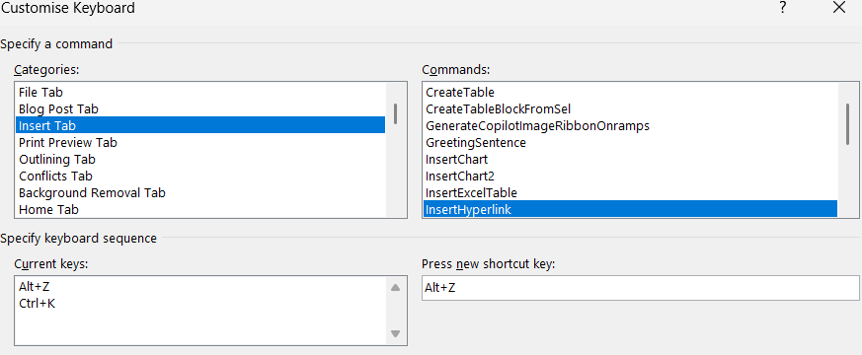
Step 3. In the window that opens, go to Categories-Insert tab (see below) and Commands-EditBookmark-Ctrl+B-Assign.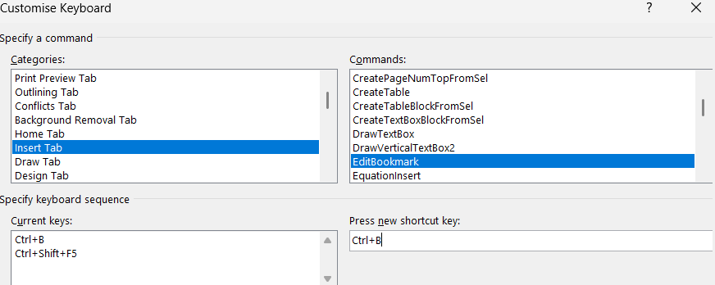

Step 4. Select the References heading, press Ctrl+B, and enter the following command: Bookmark name: References-add.
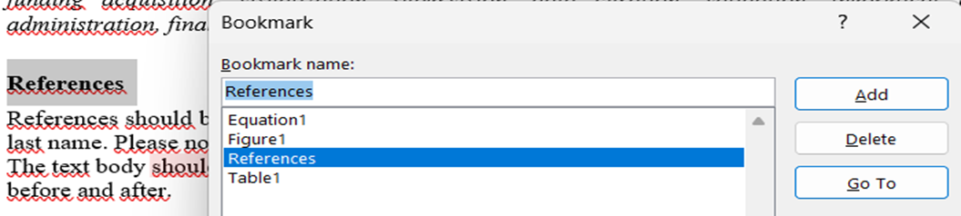
Step 5. For each citation used in the text, select the year of citation and press the Alt+Z shortcut, then Insert link-Place in This Document-References-OK.
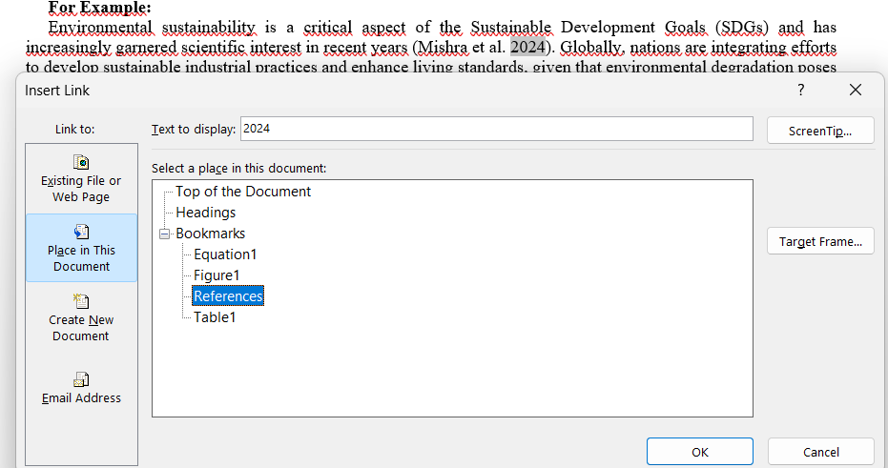

Corresponding author.

